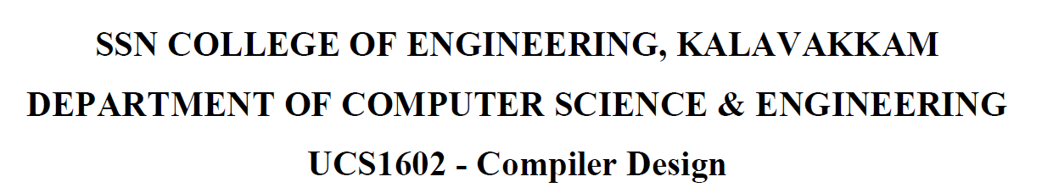

**Programming Assignment-9 Implementation of code generation**

Name: Jayannthan P T

Dept: CSE ‘A’

Roll No.: 205001049

Source Code:

Lex file:

%{

#include<stdio.h>

#include<stdlib.h>

#include "y.tab.h"

void yyerror(char*);

extern YYSTYPE yylval;

%}

digit   [0-9]

letter  [a-zA-Z]

identifier (_|{letter})(_|{digit}|{letter})* relop(<)|(>)|(<=)|(>=)|(==)|(!=) arithop(\+)|(\-)|(\*)|(\/)

space(\ )

%%

    if  {yylval.string=strdup(yytext);return ifStmt;} goto {yylval.string=strdup(yytext);return gotoStmt;}

    L{digit}    {yylval.string=strdup(yytext);return label;} t{digit} {yylval.string=strdup(yytext);return tempVar;}

    {identifier}       {yylval.string=strdup(yytext);return identifier;}

    {digit}+    {*/*printf("%s\n",yytext);*/*yylval.string=strdup(yytext);return number;}

    \:  {return *yytext;}

    \n  {return *yytext;}

    {relop} {yylval.string=strdup(yytext);return relop;}

    {arithop} {yylval.string=strdup(yytext);return arithop;}

    =   {return *yytext;}

    {space} {return *yytext;}

%%

**Yacc file:**

%{

#include<stdio.h> #include<stdlib.h> #include<string.h> #include "registersTable.h" #include "y.tab.h"

int yylex(void); void

yyerror(char*); int yywrap(void);

char* hasRegister(char*);

void checkRelop(char*,char*);

char* checkArithop1(char*,char*,char*); char* checkArithop2(char*,char*,char*); extern FILE *yyin;

int register_count=0; registers reg[20];

%}

%union

{ char

*string; int num;

};

%token <string> ifStmt gotoStmt label tempVar identifier relop arithop number

%type <string> Var ArithExpr

%%

S:  S Line

| Line

;

Line:   label ':' ' ' Var '=' number '\n' {

char *newReg=hasRegister($4);

if(newReg==NULL)

{

newReg=(char*)malloc(sizeof(char)*10);

sprintf(newReg,"R%d",register_count);

reg[register_count].var=strdup($4);

reg[register_count].registerName=strdup(newReg);

register_count+

+;

}

printf("MOV %s,#%s\n",newReg,$6);

}

|Var '=' number '\n'

{ char *newReg=hasRegister($1); if(newReg==NULL)

{

newReg=(char*)malloc(sizeof(char)*10); sprintf(newReg,"R

%d",register_count); reg[register_count].var=strdup($1); reg[register_count].registerName=strdup(newReg); register_count++;

}

printf("MOV %s,#%s\n",newReg,$3);

}

$1,hasRegister($4),hasRegister($6));

}

| label ':' ' ' Var '=' tempVar '\n' {

*//printf("%s: MOV %s,%s\n",*

|Var '=' tempVar '\n' {

*//printf("MOV %s,%s\n",hasRegister($1),hasRegister($3));*

}

| label ':' ' ' Var '=' ArithExpr '\n' {

printf("%s: %s",$1,$6);

}

|Var '=' ArithExpr '\n'

{ printf("%s",$3);

}

| label ':' ' ' ifStmt ' ' Var relop number ' ' gotoStmt ' '

{

*newReg=(char*)malloc(sizeof(cha r)*10);

%d",register_count);

%s\n",newReg,$8);

*reg=hasRegister($6);

%s\n",$1,reg,newReg);

char

}

sprintf(newReg,"R

register_count++; printf("MOV %s,#

char

printf("%s: CMP %s, checkRelop($7,$12);

'\n'

*newReg=hasRegister($8);

*reg=hasRegister($6);

%s\n",$1,reg,newReg);

| label ':' ' ' ifStmt ' ' Var relop Var ' ' gotoStmt ' ' label

{

}

|gotoStmt ' ' label '\n' {

char char

printf("%s: CMP %s,

checkRelop($7,$12);

printf("JMP %s\n",$3);;

}

;

ArithExpr:  Var arithop Var {

$

$=strdup(checkArithop1($2,$1,$ 3));

number {

| Var arithop

$

$=strdup(checkArithop2($2,$1,$3));

}

;

Var: identifier {$$=strdup($1);}

%%

| tempVar   {$$=strdup($1);}

;

char* hasRegister(char* *var*) {

for(int i=0;i<register_count;i++)

{

if(strcmp(*var*,reg[i].var)==0)

{

return (char*)reg[i].registerName;

}

}

return NULL;

}

void checkRelop(char* *relop1*,char* *label1*)

{ if(strcmp(*relop1*,">")==0)

{

printf("JGT %s\n",*label1*);

} else if(strcmp(*relop1*,">=")==0)

{

printf("JGE %s\n",*label1*);

} else if(strcmp(*relop1*,"<")==0)

{

printf("JLT %s\n",*label1*);

} else if(strcmp(*relop1*,"<=")==0)

{

printf("JLE %s\n",*label1*);

} else if(strcmp(*relop1*,"!=")==0)

{

printf("JNE %s\n",*label1*);

} else if(strcmp(*relop1*,"==")==0)

{

printf("JE %s\n",*label1*);

}

}

char* checkArithop1(char* *arithop1*,char* *var1*,char* *var2*) { char

*code=(char*)malloc(sizeof(char)*128);

*//printf("*Here\n"); if(strcmp(arithop1,"+")*

==0)

{

sprintf(code,"ADD %s,%s\ n",hasRegister(var1),hasRegister(var2));

} else if(strcmp(arithop1,"-")==0)

{

sprintf(code,"SUB %s,%s\n",hasRegister(var1),hasRegister(var2));

} else if(strcmp(arithop1,"*")==0)

{

sprintf(code,"MUL %s,%s\ n",hasRegister(var1),hasRegister(var2));

} else if(strcmp(arithop1,"/")==0)

{

sprintf(code,"DIV %s,%s\n",hasRegister(var1),hasRegister(var2));

}

return code;

}

char* checkArithop2(char* *arithop1*,char* *var1*,char* *num*) { char

*newReg=(char*)malloc(sizeof(char)*10); sprintf(newReg,"R%d",register_count); register_count++;

*//printf("Here*\n");*

char *code=(char*)malloc(sizeof(char)*128);

*//printf("Here**\n");*

char *code1=(char*)malloc(sizeof(char)*64); sprintf(code1,"MOV %s,#%s\ n",newReg,*num*);

*//printf("Here***\n"); if(strcmp(arithop1,"+")*

==0)

{

sprintf(code,"%sADD %s,%s\ n",code1,hasRegister(var1),newReg);

} else if(strcmp(arithop1,"-")==0)

{

sprintf(code,"%sSUB %s,%s\n",code1,hasRegister(var1),newReg);

} else if(strcmp(arithop1,"*")==0)

{

sprintf(code,"%sMUL %s,%s\ n",code1,hasRegister(var1),newReg);

} else if(strcmp(arithop1,"/")==0)

{

}

return code;

}

sprintf(*code*,"%sDIV %s,%s\n",*code1*,*hasRegister*(var1),newReg);

void yyerror(char \**str*)

{

fprintf(stderr,"%s\ n",*str*); return;

}

int yywrap()

{

return 1;

}

int main(int *argc*,char \**argv*[])

{

yyin=fopen(*argv*[1],"r");yyparse(); return 0;

}

**Header file used:**

typedef struct registers

{

    char *var;

    char *registerName;

} registers;

**Output**

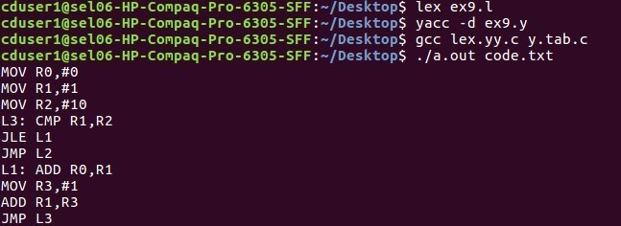 **RESULT:**

Machine code for given three address code is generated successfully.